**Selenium Locators Assignment:**

**Problem 1**- Open 4 web

|  |
| --- |
| [https://phptravels.net/api/uploads/globallogo.png](https://phptravels.net/api/uploads/global/logo.png) |

site and locate the following and Write xpath.

* PHPTRAVLES Logo :

**Absolute path:** /html/body//img[contains(@src, 'logo') or contains(@id, 'logo') or contains(@class, 'logo')]

**Relative path:** //a[text()='Home']

* Home:

**Absolute path:** /html/body//a[text()='Home']

**Relative path:** //a[text()='Home']

* Flights

**Absolute path:** /html/body//a[text()='flights']

**Relative path:** //a[text()='flights']

* Tours

**Absolute path:** /html/body//a[text()='Tours']

**Relative path:** //a[text()='Tours']

* Company

**Absolute path:** /html/body//li[@class='footm']

**Relative path:** //li[@class='footm']

* Signup Btn

**Absolute path:** /html/body//a[@class='theme-btn theme-btn-small waves-effect']

**Relative path:** //a[@class='theme-btn theme-btn-small waves-effect']

* Login Btn

**Absolute path:** /html/body//a[@class='theme-btn theme-btn-small theme-btn-transparent ml-1 waves-effect']

**Relative path:** //a[@class='theme-btn theme-btn-small theme-btn-transparent ml-1 waves-effect']

* Agents DropDown

**Absolute path:** /html/body//button[@id='agents']

**Relative path:** //button[@id='agents']



*Note - You have to use Id, Name, Class, CSS Selector, TagName and write Relative and absolute xpath*

**Problem 2**- Write **Xpath** for Below Web elements using Xpath Axes (such as preceding, following, ancestor, following-sibling etc..)

* Check in - Calendar Icon

//*[@id="hotels-search"]/div/div/div[2]/div/div[1]/div/span//parent::div

* Check Out – Calendar Icon

//*[@id="hotels-search"]/div/div/div[2]/div/div[2]/div/span//parent::div

* “- ” for Adults

//*[@id="hotels-search"]/div/div/div[3]/div/div/div/div/div[2]/div/div/div[1]//parent::div

* “+” for Adults

//*[@id="hotels-search"]/div/div/div[3]/div/div/div/div/div[2]/div/div/div[1]//parent::div

* “-“ for Childs

//*[@id="hotels-search"]/div/div/div[3]/div/div/div/div/div[3]/div/div/div[1]/i//parent::div

* “+” for Childs

search"]/div/div/div[3]/div/div/div/div/div[3]/div/div/div[2]/i//parent::div

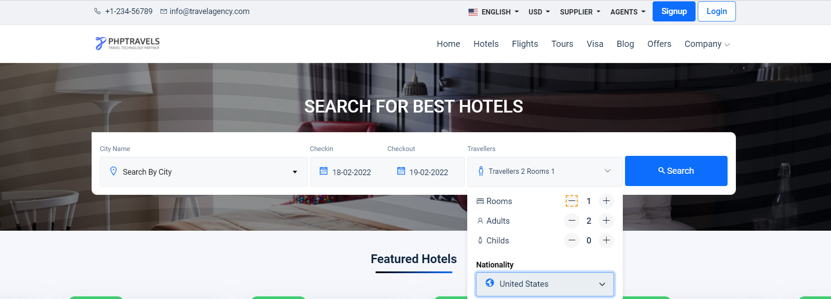

**Note : Don’t Use Indexes**